***19th June 2020***

*Examples of Normalised Average (n/a) IMU Stride Data*

Because Equine motion in all gaits is cyclic the approached adopted for the analysis for motion time histories is first to select a period of constant speed data and then form a normalized average (n/a) of a selected number of strides.

**Normalising** means adjusting all strides to have the same stride time as the average time, and for the data to be interpolated to have the same number of data points.

**Averaging** means that at each data time the amplitudes of the selected strides are averaged.

Examples of this process for six data channels from an Inertial Measurement Unit (IMU) fitted to the hoof of a horse are shown below.

The plots show the stride-to stride variability of 5 strides and the normalised/ average (n/a) value for the pitch rate channel.

The n/a time histories can be used in further analysis, for example the n/a value for pitch rate can be integrated to produce hoof pitch angle during a single stride.

*Accelerations*

ax ay

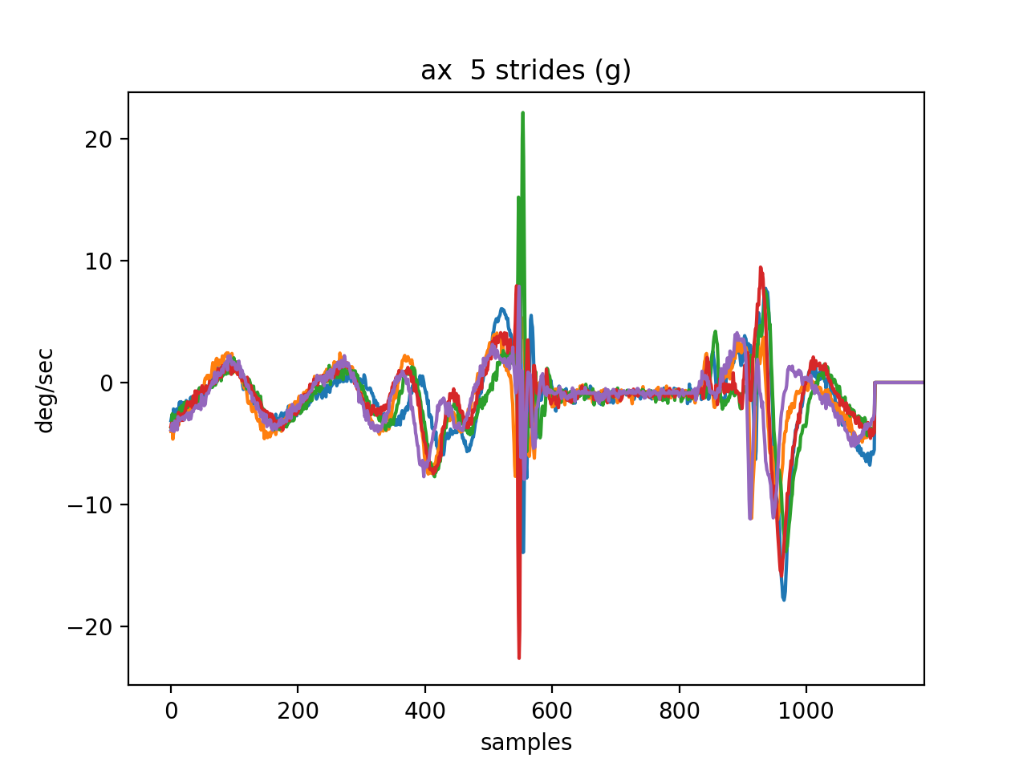 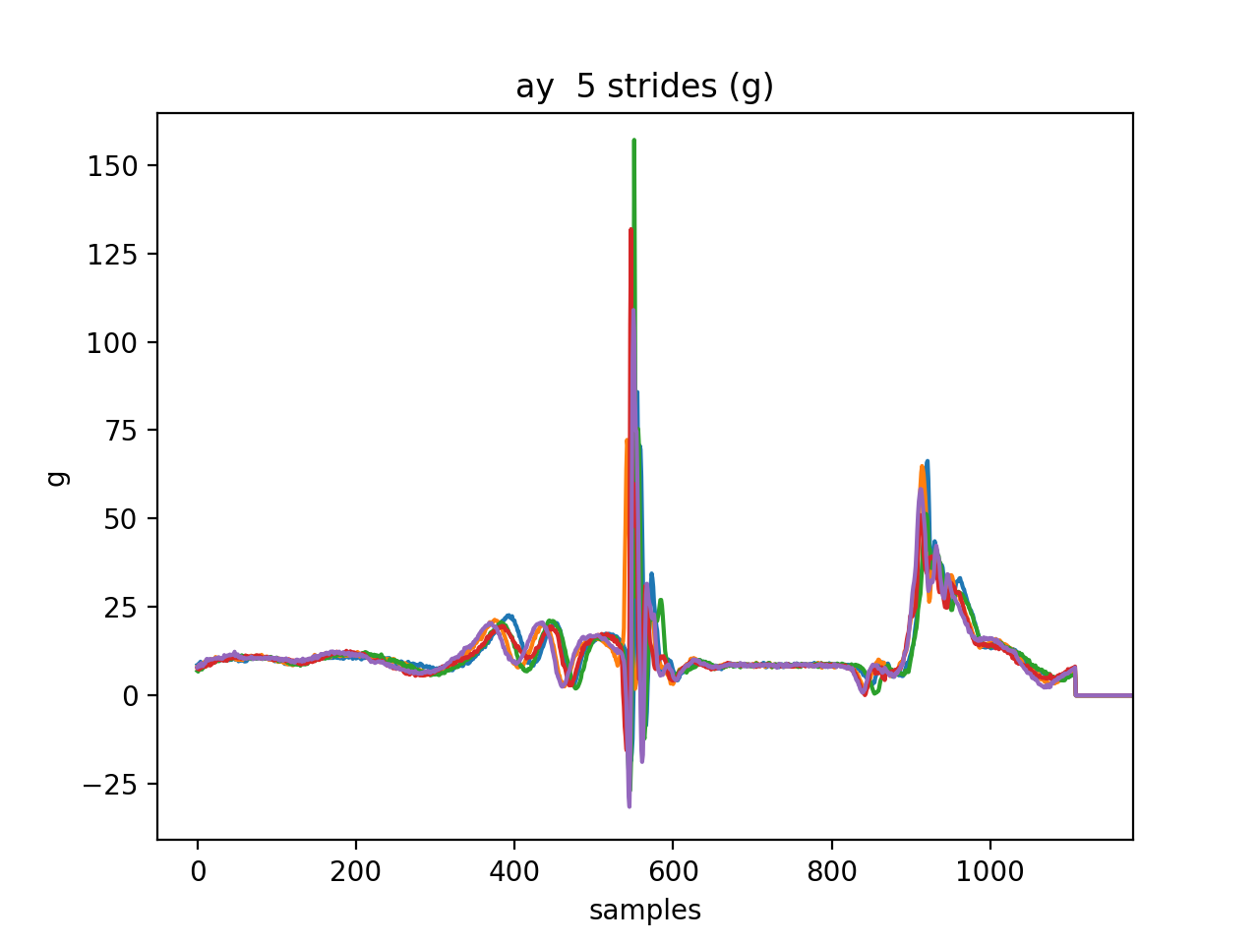

az

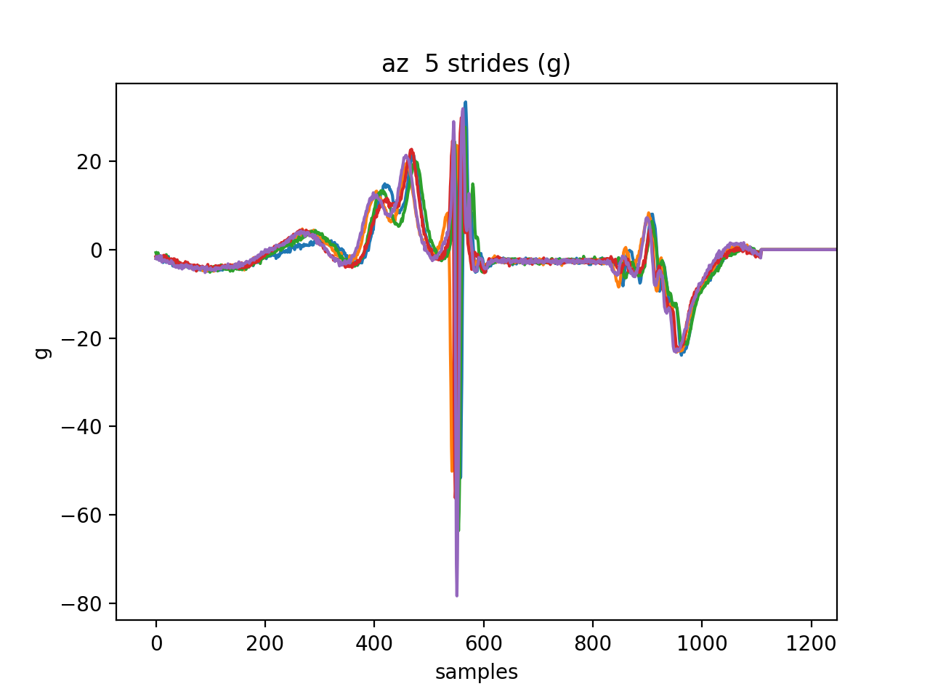

*Angular rates*

Pith rate (q) roll rate (p) yaw rate (r)

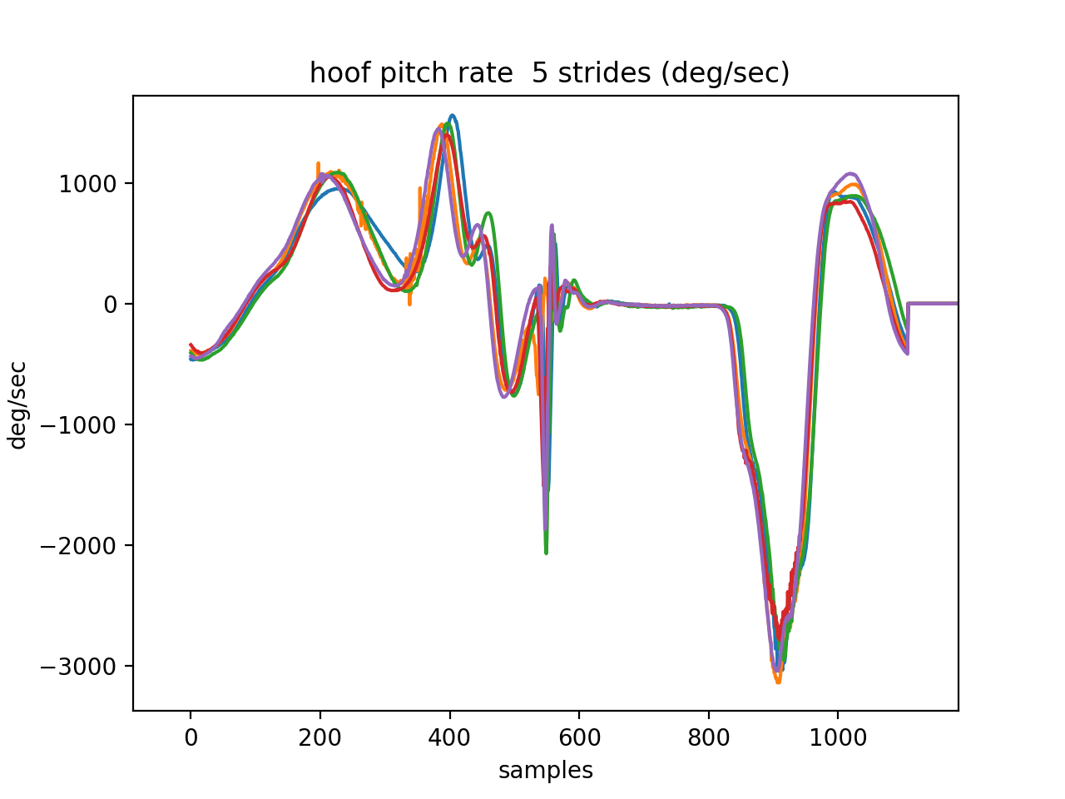 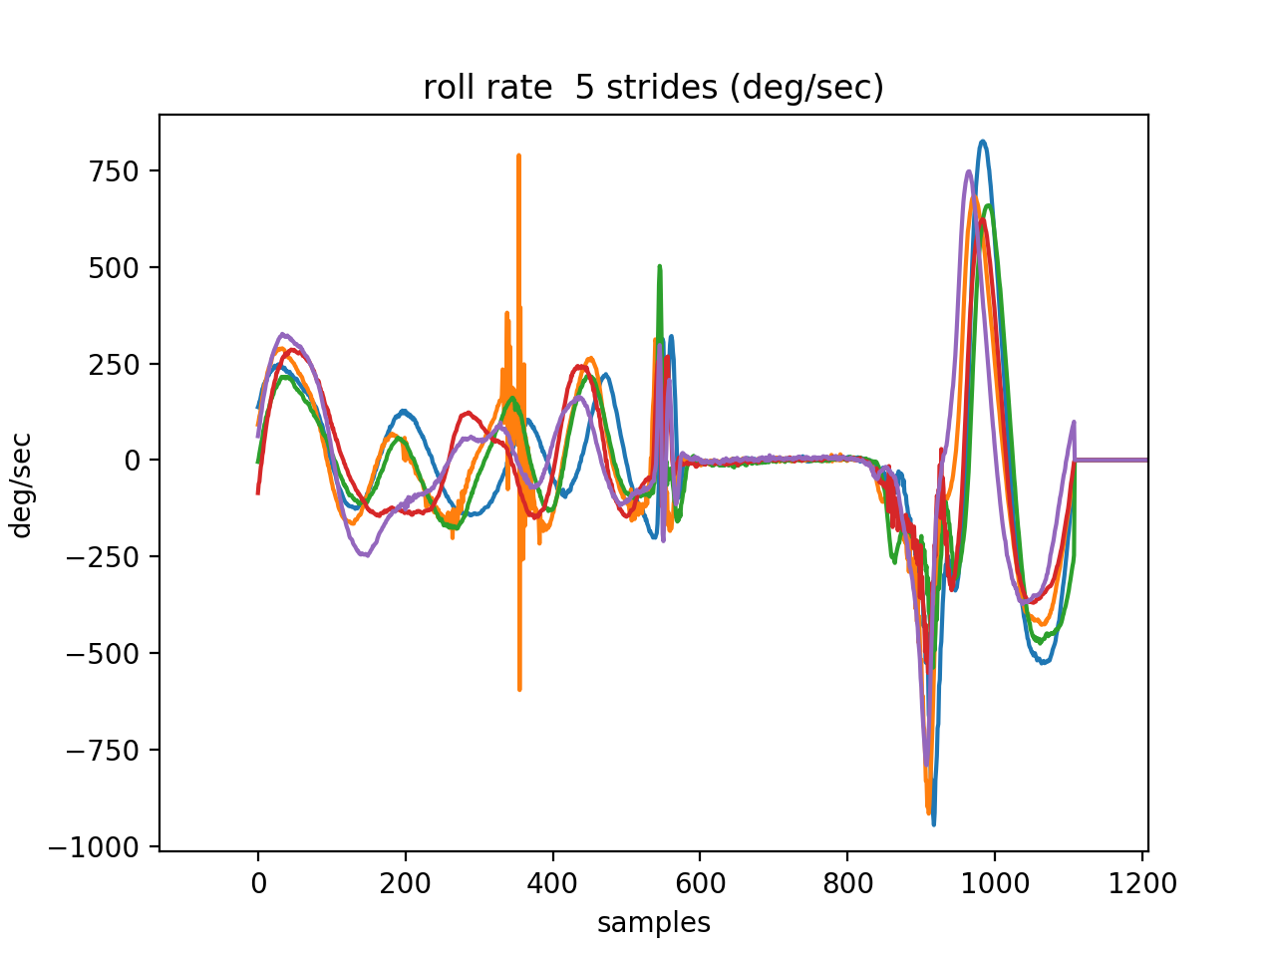 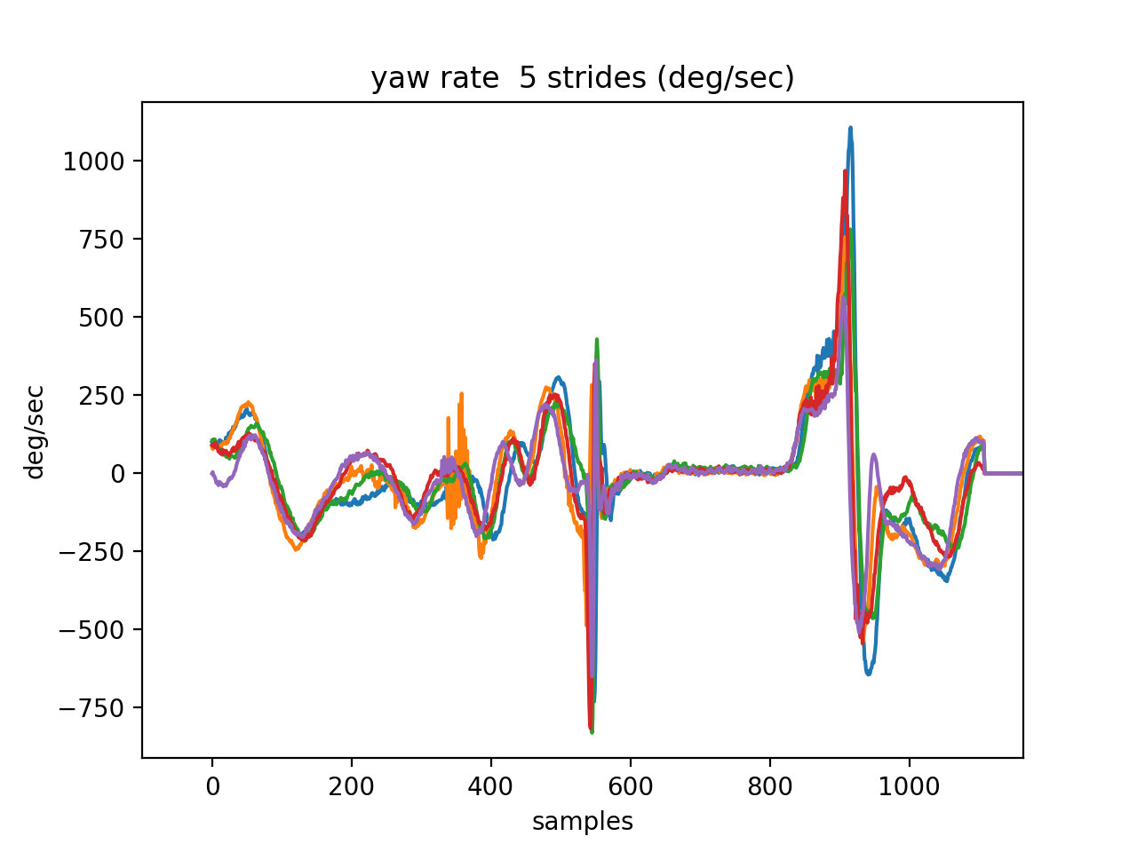

Example of Normalised Average (n/a) for pitch rate compared with single stride 5.

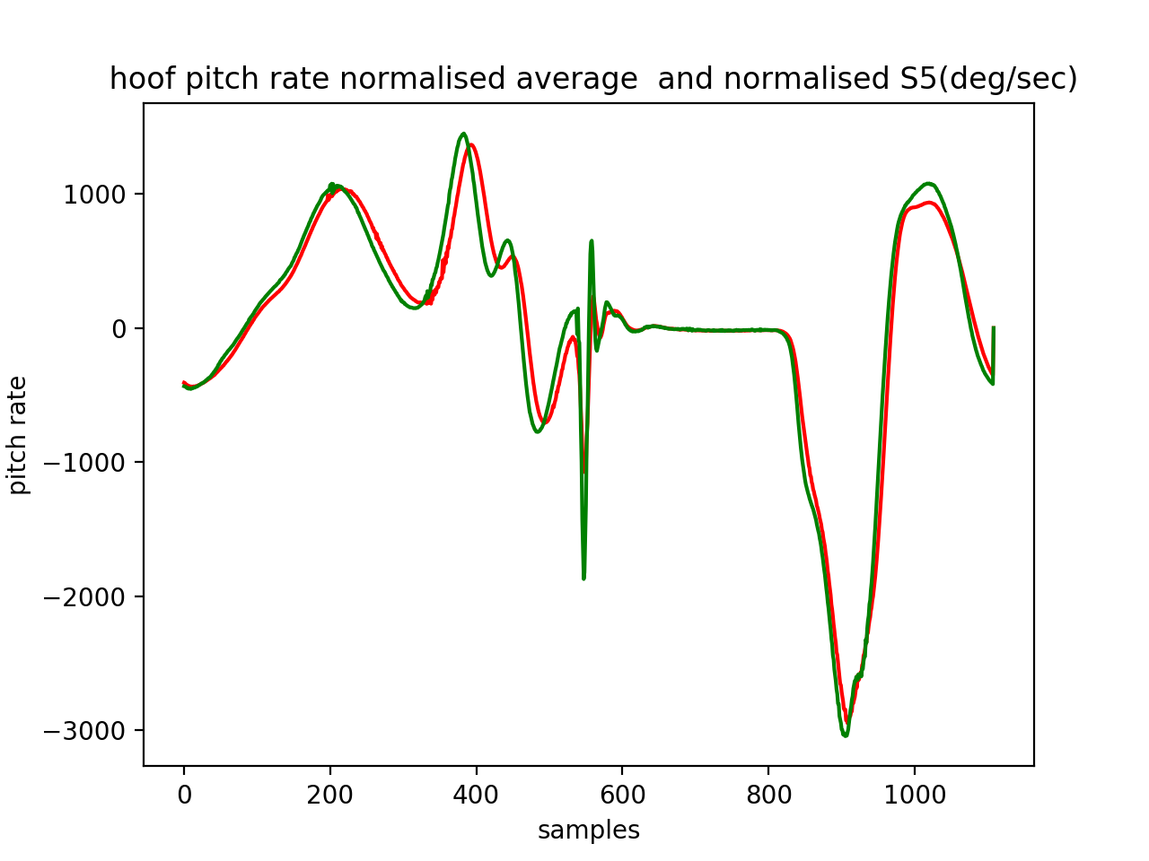

Integration of n/a pitch rate q to produce hoof pitch angle theta.

